**Model Predictive Control Based Jumping of Robotic Leg on a Particular height using Reinforcement Learning**

**Risks and challenges-**

**1. Project Stakeholders**

**Stakeholder List and Roles**

Project Team - Engineers, data scientists, and project managers responsible for the design, development, and deployment of the robotic leg.

Supervising Academic Faculty - Provides guidance, technical support, and ensures project aligns with academic goals.

Research Organizations - Potential collaborators offering resources, data, or funding for research purposes.

Industry Partners - Robotics companies or labs interested in leveraging this project for commercial applications.

End Users - Those who will ultimately benefit from the robotic leg technology (e.g., medical, military, or logistics sectors).

Sponsors - Entities providing financial support for the project, including grants or company funds.

Stakeholder Relationships

Project Team and Supervising Academic Faculty - Faculty guide the team’s research approach, technical strategy, and ensure project viability.

Research Organizations and Project Team - Collaboration on data-sharing and joint research initiatives.

Industry Partners and End Users - Industry partners may support product commercialization, while end users’ needs guide feature development.

**2. Business Goals and Target Users**

Business Goals: Develop a high-precision, adaptable robotic leg for jumping, combining the control reliability of MPC with the adaptability of RL.

Target Users: Primarily researchers and industry developers in robotics, with potential applications in healthcare, military, and industrial logistics.

**3. Project Challenges**

**A. Technical Challenges**

Integration of MPC and RL: Combining MPC’s deterministic control with RL’s adaptability presents integration complexity.

Real-Time Processing: High computational demands may lead to latency issues, which can disrupt precise movements.

Sensor Reliability: Sensors must provide accurate data for both MPC and RL models to function effectively.

Data Collection for RL Training: RL requires large datasets for training, which can be costly and time-consuming to obtain physically.

**B. Practical and Operational Challenges**

Resource Constraints: Access to high-quality hardware, computing resources, and funding may limit project scope.

Project Timeline: Delays in data collection or model training may lead to timeline overruns.

Wear and Tear on Hardware: Repeated physical testing of jumps can cause mechanical strain on the robotic leg components.

**C. Competitive Challenges**

Market Alternatives: Competing projects may employ different methods for similar results, such as entirely RL-based control.

Differentiation: Establishing unique value through hybrid MPC-RL to create a balance between adaptability and precision.

**4. Project Risks**

Key Areas of Risk and Mitigation Strategies

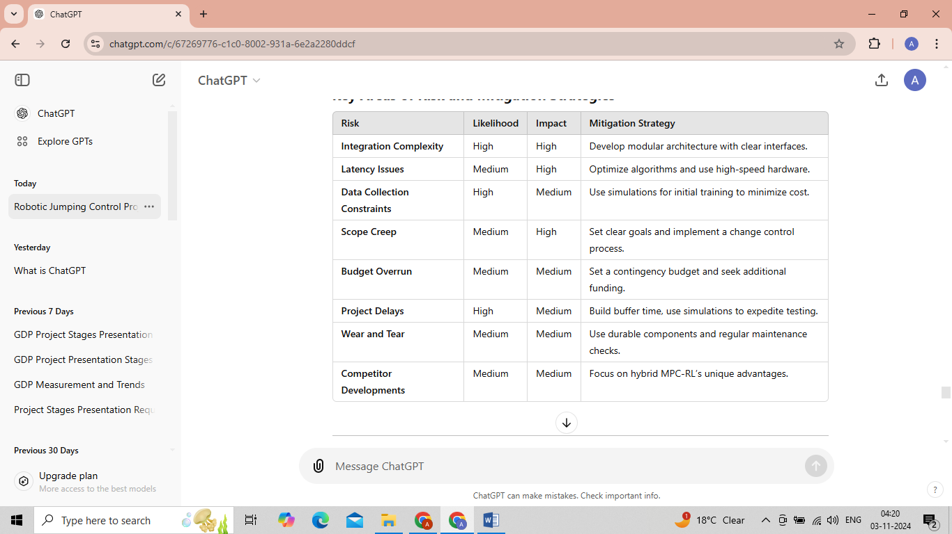

**5. Solutions to Challenges**

**A. Technical Solutions**

Modular System Design:

Separate MPC and RL modules to streamline integration and simplify debugging.

Establish clear communication interfaces between modules to allow dynamic data sharing without latency issues.

Simulation-Based Training:

Use simulated environments to train RL models before transitioning to real-world testing, reducing data collection costs and hardware wear.

Algorithm Optimization:

Simplify state-space representation for RL and optimize MPC calculations to minimize computational load and achieve low-latency operation.

High-Precision Sensors:

Employ sensor fusion techniques to improve data accuracy, ensuring MPC and RL algorithms receive precise and reliable inputs.

**B. Practical Solutions**

Clear Scope Definition:

Outline project goals and deliverables clearly from the outset to manage stakeholder expectations and prevent scope creep.

Enhanced Resource Planning:

Allocate resources carefully, prioritize high-impact tasks, and seek additional funding sources or partnerships if required.

Durable Hardware Design:

Use high-quality, robust materials for components expected to experience repetitive mechanical stress, such as springs or actuators, to reduce maintenance frequency.

Competitor Analysis and Differentiation:

Regularly assess competitor solutions and emphasize the unique value of combining MPC’s control precision with RL’s adaptability.

**6. Risk Management Approach**

Scope Management

Challenge: Unmanaged requests for additional features or functionalities could lead to scope creep, impacting budget and timeline.

Solution: Define a project scope document and implement a change management process to evaluate new requests based on value, time, and cost.

Failure Management

Challenge: System failure during testing could set back development and damage hardware.

Solution: Develop redundancy in control algorithms to handle unexpected sensor failures and other anomalies.

Performance Testing and Iteration

Challenge: Achieving precise jumping performance while maintaining adaptability.

Solution: Set performance metrics for jumping accuracy and adaptability, and use iterative model testing to optimize these parameters.

Technology Comparison and Justification

Challenge: Different control technologies have varied pros and cons, making selection challenging.

Solution: Compare available technologies based on adaptability, precision, and resource requirements, justifying the final choice with detailed evaluation criteria.

**7. Success Criteria and Metrics**

Success Criteria:

The robotic leg should achieve a specified height with high precision and minimal latency.

The system should adapt to environmental changes with minimal adjustments.

Overall performance meets defined metrics for energy efficiency, control accuracy, and adaptability.

Metrics:

Jump Accuracy: Measure precision of each jump height.

Response Time: Track latency from command initiation to jump.

Adaptability: Assess performance consistency across varied surfaces.

Power Efficiency: Monitor energy consumption per jump.

**8. Importance of Features (Vital Business Functions)**

Adaptability - The ability to perform consistently across different terrains makes this solution valuable in real-world applications such as uneven ground.

Precision Control - Enables safe and reliable movements, essential for applications requiring high accuracy like medical assistive devices.

Scalability - The control framework should allow for adjustments in height or force, making it versatile for different use cases.

Reliability - Consistent performance with minimal errors ensures trust in industrial and commercial applications.

**9. Learning Outcomes and Team Contributions**

Learning Outcomes

Understanding MPC and RL Synergy: Gain insights into combining traditional control theory with adaptive learning.

Real-World Problem Solving: Develop problem-solving skills specific to robotics and autonomous systems.

Risk Management in Robotics Projects: Learn to anticipate and mitigate risks in high-stakes engineering projects.

Individual Development

Current Capabilities: Background knowledge in robotics, machine learning, and control systems.

Skill Enhancement: Applying academic knowledge in a practical setting to improve technical skills, project management, and collaboration abilities.

Team Contributions

Leadership: Guide project direction and maintain focus on objectives.

Technical Expertise: Contribute to algorithm development and system integration.

Support: Assist team members with troubleshooting and offer support in areas of expertise.

**10. Conclusion**

This document provides a comprehensive overview of the risks and challenges associated with the MPC-based jumping robotic leg using RL. It includes a thorough analysis of stakeholder involvement, project goals, key challenges, and risk management strategies. By following this roadmap, the project team can minimize risks, address technical challenges, and maximize project success. This document serves as a reference for stakeholders, ensuring alignment and clarity throughout the project’s lifecycle.